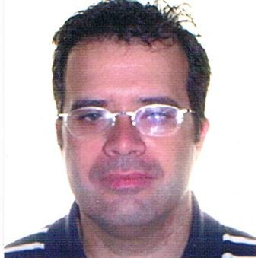

Salvador Montaner-Villalba

e-mail: smontaner@invi.uned.es

Telf. Móvil: 651.628.758

https://www.linkedin.com/in/salvadormontanerdocente/

https://www.researchgate.net/profile/Salvador_Montaner-Villalba

EDUCATION

Ph.D. at UNED 2017-2019
- Applied Computational Linguistics, Computer-Assisted Language Learning
- Theme of thesis: Implementing ICT in the English language through CLIL

M.A. in Linguistics and IT at UNED 2012-2016
- ICT & Language Teaching

B.A. in English Studies, Valencia University 1991-1996

TEACHING EXPERIENCE

Part-time Lecturer, English for Specific Purposes 2019-

Applied Linguistics Dept., Valencian Polytechnics University

Teacher Training 2016-
- ICT & Languages
- ICT & CLIL
- Speaker at both national and international conferences

EFL Teacher, Education Dept., Valencia 2002-

Online Lecturer at VIU (Valencian International University) 2016-2018

EDUCATIONAL VOLUNTEERING

Chair of CMC SIG at EuroCALL, Sept. 2018-

LANGUAGES

B2 Goethe-Zertifikat

